**10-Amaliy ish.**

PHPda satrlar, massivlar, fayllar va formalar bilan ishlash.

Pasda PHP da berilgan kodlarni ishlashi uchun open server yoki xampp yoki boshqa server dasturlaridan birini o`rnatish shart bo`ladi aks holda kodni ishlatish imkoni bo`lmaydi. Xar bir misol istalgan redaktorda yozilgandan so`ng uni birnarsa.php deb tegish joyga saqlash kerak.

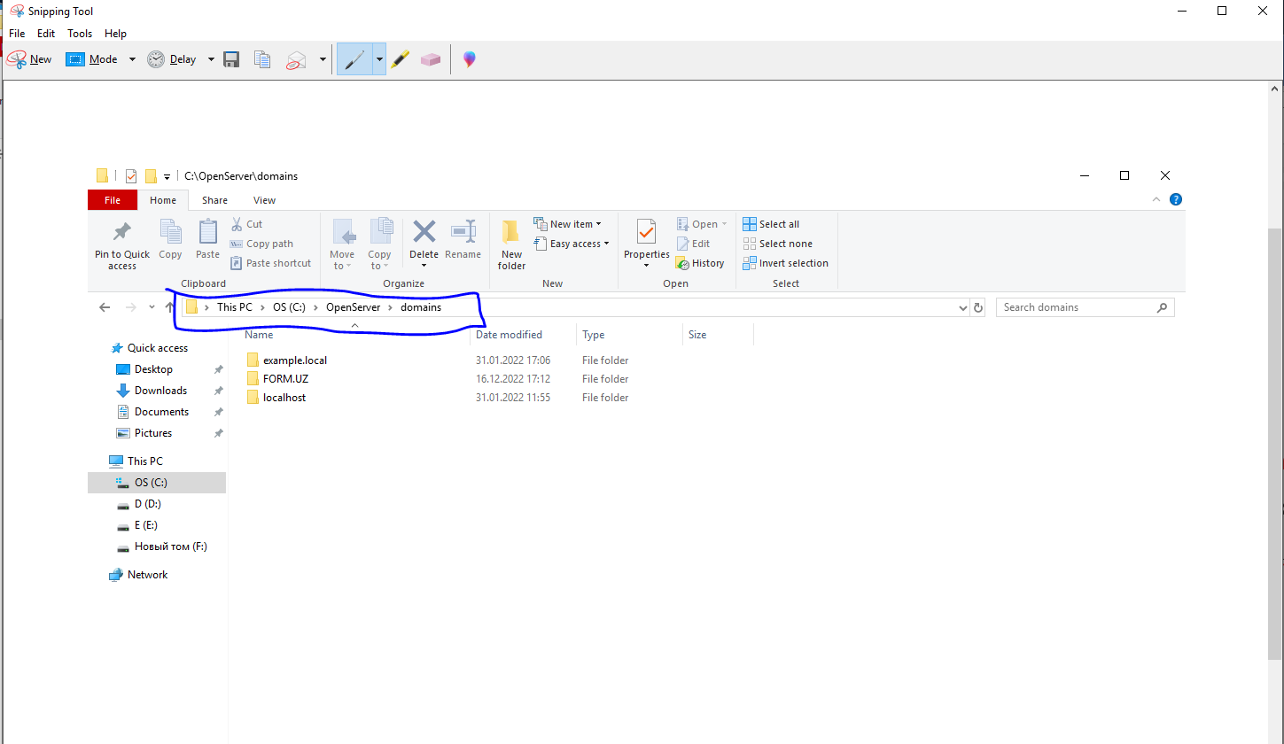

Menda C diskda open server ichida domain papka ichida yuqorida ko`rsatilgan papkalar ichida joylashgan. Misolni saqlagandan keyin serverni ishga tushurish lozim bo`ladi.

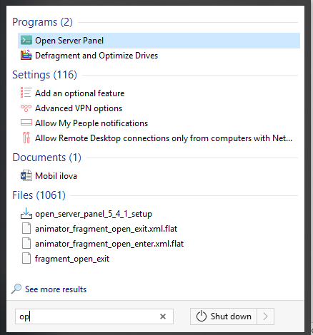

Open serverni ishga tushurib zapustit qilish kerak. Zapustit qilish kompyuterning o`ng tomoni soat oldida chiqadi

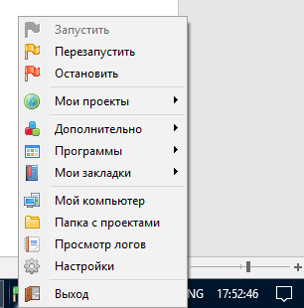

Menda zapustit qilish aktiv turibdi agar kodlarimda biror o`zgarish bo`lsa perezapustit qilishni o`zi kifoya. Endi menda formaga tegishli bo`lgan misolni ishga tushirib ko`rsataman. Kerakli misollarni brauzer orqali ko`rish uchun yuqoridagi moy proekt bo`limidan tanlab yoki shunchaki papka qanday nomlangan bo`lsa brauzer qidiruv oynasiga papka nomini yozishni o`zi kifoya. Demak brauzer orqali ochishni ko`rib chiqamiz.

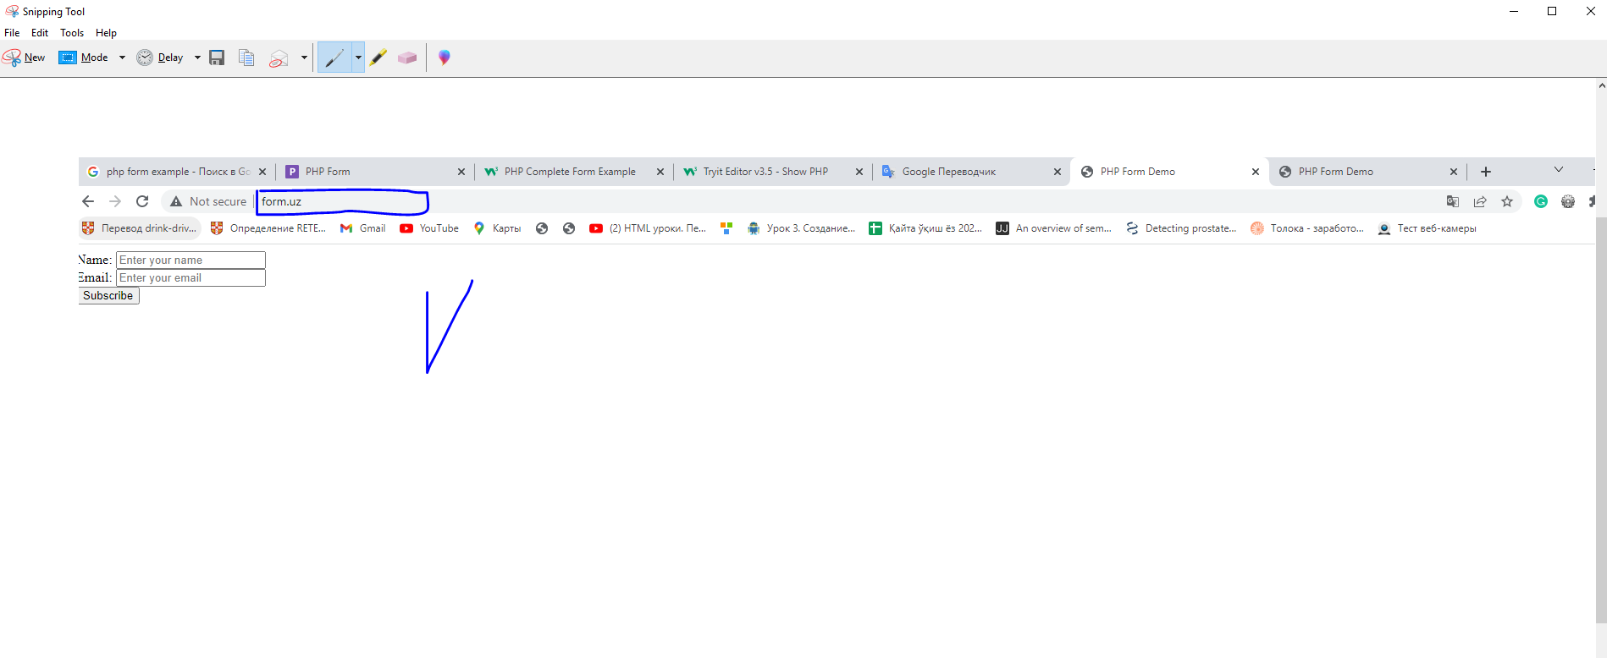

Yuqoridagi rasmga e`tibor qilsangiz men shunchaki form.uz yozish orqali kerakli misolni ishga tushurdim.

1. <!DOCTYPE html>

<html>

<body>

<?php

echo "My first PHP script!";

?>

</body>

</html>

1. <!DOCTYPE html>

<html>

<body>

<?php

$txt = "PHP";

echo "I love $txt!";

?>

</body>

</html>

1. <!DOCTYPE html>

<html>

<body>

<?php

// This is a single-line comment

# This is also a single-line comment

?>

</body>

</html>

1. <!DOCTYPE html>

<html>

<body>

<?php

// You can also use comments to leave out parts of a code line

$x = 5 /* + 15 */ + 5;

echo $x;

?>

</body>

</html>

1. <!DOCTYPE html>

<html>

<body>

<?php

$txt = "Hello world!";

$x = 5;

$y = 10.5;

echo $txt;

echo "<br>";

echo $x;

echo "<br>";

echo $y;

?>

</body>

</html>

1. <!DOCTYPE html>

<html>

<body>

<?php

$x = 5; // global scope

function myTest() {

// using x inside this function will generate an error

echo "<p>Variable x inside function is: $x</p>";

}

myTest();

echo "<p>Variable x outside function is: $x</p>";

?>

</body>

</html>

1. <!DOCTYPE html>

<html>

<body>

<?php

function myTest() {

$x = 5; // local scope

echo "<p>Variable x inside function is: $x</p>";

}

myTest();

// using x outside the function will generate an error

echo "<p>Variable x outside function is: $x</p>";

?>

</body>

</html>

1. <!DOCTYPE html>

<html>

<body>

<?php

$txt1 = "Learn PHP";

$txt2 = "W3Schools.com";

$x = 5;

$y = 4;

echo "<h2>" . $txt1 . "</h2>";

echo "Study PHP at " . $txt2 . "<br>";

echo $x + $y;

?>

</body>

</html>

1. <!DOCTYPE html>

<html>

<body>

<?php

$cars = array("Volvo", "BMW", "Toyota");

echo "I like " . $cars[0] . ", " . $cars[1] . " and " . $cars[2] . ".";

?>

</body>

</html>

FORMA BILAN ISHLASH

1. Bu misolni ham yuqorida berilgan tavsiya orqali open server dasturi o`rnatilgan joyda domain papka ichiga ixtoyoriy nom berish orqali papka yaratib birnarsa.php deb saqlaymiz.

<!DOCTYPE html>

<html lang="en">

<head>

<meta charset="UTF-8" />

<meta name="viewport" content="width=device-width, initial-scale=1.0" />

<link rel="stylesheet" href="css/style.css">

<title>PHP Form Demo</title>

</head>

<body>

<main>

<form action="subscribe.php" method="post">

<div>

<label for="name">Name:</label>

<input type="text" name="name" required="required" placeholder="Enter your name" />

</div>

<div>

<label for="name">Email:</label>

<input type="email" name="email" required="required" placeholder="Enter your email" />

</div>

<button type="submit">Subscribe</button>

</form>

</main>

</body>

</html>

1. Yuqoridagi kodga e`tibor qilsangiz kod ichida subscribe.php fayliga yo`l ko`rsatilgan quyida esa shu faylni kodini ko`rsatib o`tdim.

<?php

//---------------------------------------------

// WARNING: this doesn't include sanitization

// and validation

//---------------------------------------------

if (isset($_POST['name'], $_POST['email'])) {

$name = $_POST['name'];

$email = $_POST['email'];

// show the $name and $email

echo "Thanks $name for your subscription.<br>";

echo "Please confirm it in your inbox of the email $email.";

} else {

echo 'You need to provide your name and email address.';

}

1. Ikda kodlar jamlanmasini bitta papka ichiga joylab uni brauzer orqali natijasini ko`ra olamiz.

BAJARISH SHART BO`LGAN TOPSHIRIQ

1. Yuqoridagi berilgan tayyor kodlarni ishlatib analiz qilib savol javobga tayyorlanib kelish.